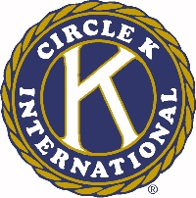
The 46th Annual Ohio District Circle K Convention

Ken Creasey Award

Circle K Club of __________________________________________________________

Permanent Mailing Address_________________________________________________
________________________________________________________________________

Official Club Membership_______________ (Number of Dues Paid Members)

The Ken Creasey Award, named after the first International President who was from the Ohio District, will be given to the club which improves the most over the District Administrative year. To compete for this award, any club with dues paid, must submit its Achievement Award entry from the previous administrative year. If no Achievement Award entry is available the current club president must submit a statement of the initial state of the club at the time of the previous convention, which must be signed by the Circle K club president, Faculty or Kiwanis Advisor and the Circle K Lt. Governor for that division. Award forms must be accompanied by a maximum 500 word, double-spaced, typewritten report on the club's improvement over the past year, using specifics. (These could include: agendas, membership totals, project samples, etc.)

Please include:

1. Daniel J. Romanello Sr. Club Achievement Award from the previous year
or
Statement from club president about the state of the club at the time of the previous
convention.
and

2. 500 word essay (explained above)

